1. Labelled diagrams of a Wi-Fi router and a network switch

- Wi-Fi router

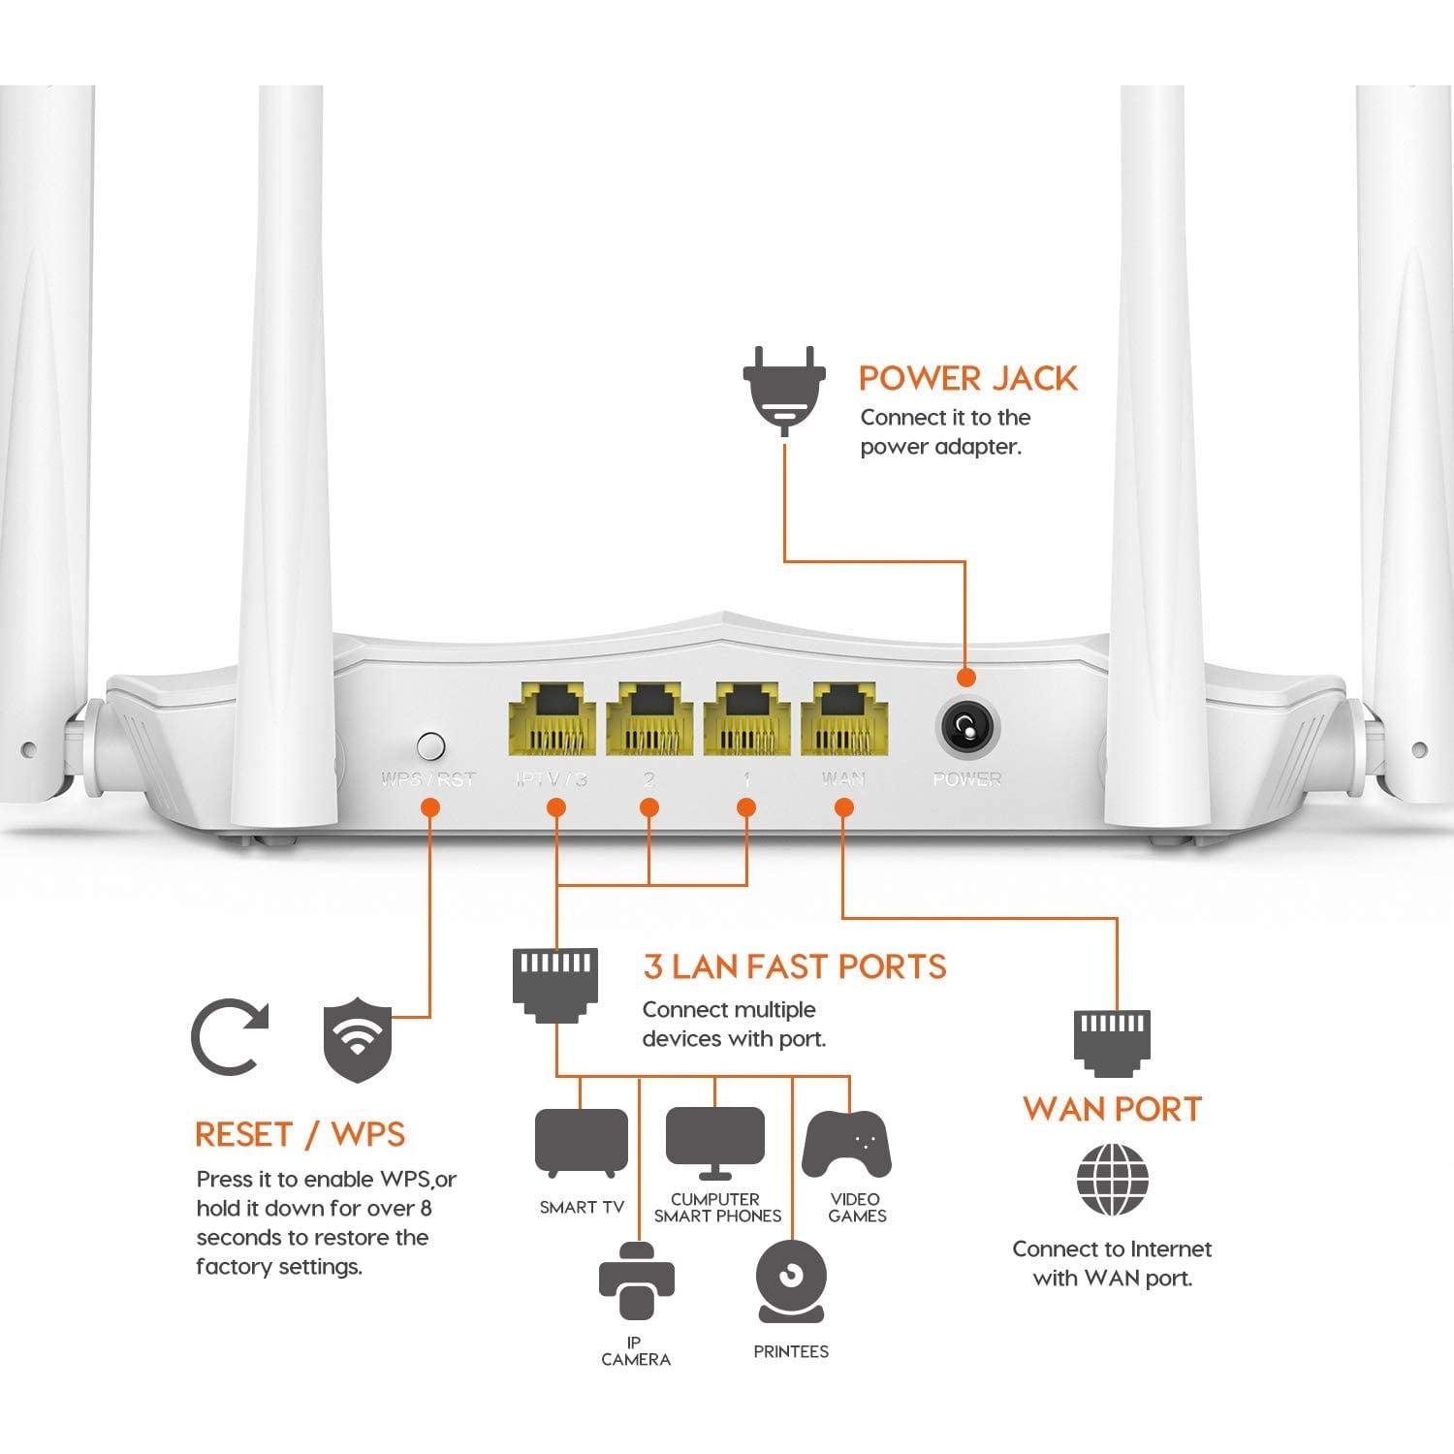

- Network switch

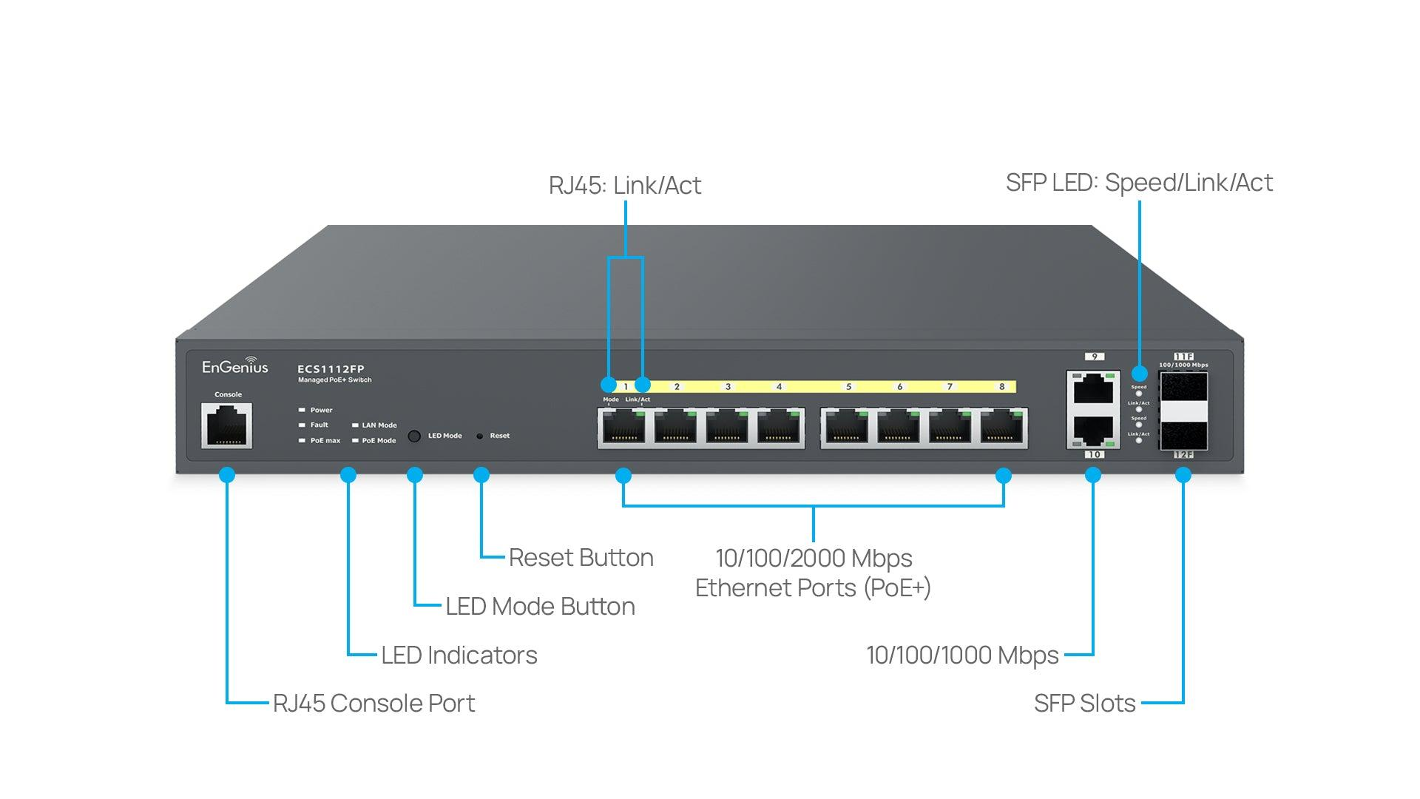

2. Three key differences between routers and switches
 | Router | Switch
Main function | Connects different networks, such as a home network and the internet. | Connects multiple devices within the same local area network (LAN).
Addresses used | Uses IP addresses to decide where to send packets. | Usually uses MAC addresses to forward Ethernet frames.
Network traffic | Routes traffic between different networks. | Forwards traffic to the appropriate port within the LAN.

3 : Identify ports and LED indicators on the images

- Router identification
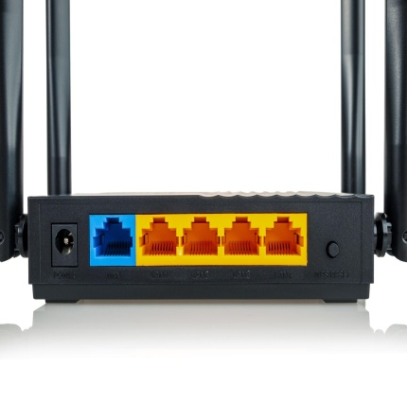

1. Power port: Usually at the back, often near the power switch. It connects the adapter.
2. Ethernet ports: The WAN port connects to the modem, while LAN ports connect computers or a switch.
3. LED indicators: Usually on the front or top; they indicate power, internet, Wi-Fi, and network activity.
- Switch identification
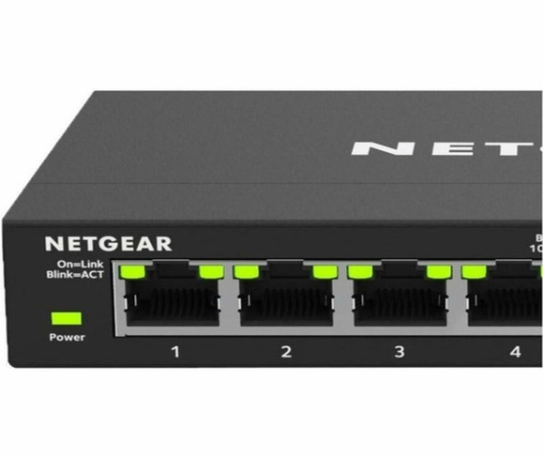
1. Power port: Usually on the rear or side; it supplies power.
2. Ethernet ports: Multiple RJ45 ports connect PCs and other wired devices.
3. LED indicators: Located near the ports; they show whether a device is connected and whether data is being transmitted.

4 : Gaming Café Network Scenario
If I set up a small gaming café for IPL streaming and multiplayer matches, I would connect the router first to the ISP's internet connection through a modem or ONT. The router would manage internet access and route data between the café's network and the internet.
Next, I would connect the router's LAN port to a network switch using an Ethernet cable. Then, I would connect all 8 gaming PCs to the switch using separate Ethernet cables.
Justification: The router provides internet connectivity, while the switch connects all eight PCs to the same local area network (LAN). Wired connections provide more stable performance and lower latency for multiplayer gaming and smooth IPL streaming.

